Exercise 7: Return Data from a Scalar Function

create function fn_CalculateAnnualSalary(@employeeid int)
returns decimal(12,2)
as begin declare @annualsalary decimal(12,2)
select @annualsalary=salary*12
from employees where @employeeid=@employeeid;
return @annualsalary;
end;
select dbo.fn_CalculateAnnualSalary(1) as annualsalary;
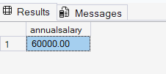

select employeeid, firstname, lastname, salary
from employees
where employeeid = 1;
